Project Design Phase-II
Data Flow Diagram & User Stories

Date | 16-10-2026
Team ID | HP-MERN-2026
Project Name | HotelPro — Human-Centered Hotel Management System
Maximum Marks | 4 Marks

Data Flow Diagrams:
A Data Flow Diagram (DFD) illustrates how data moves within the HotelPro platform. It captures how users (guests, front-desk staff, housekeeping managers, and administrators) interact with the system, how information flows between different components, and where data is stored across databases and state stores.

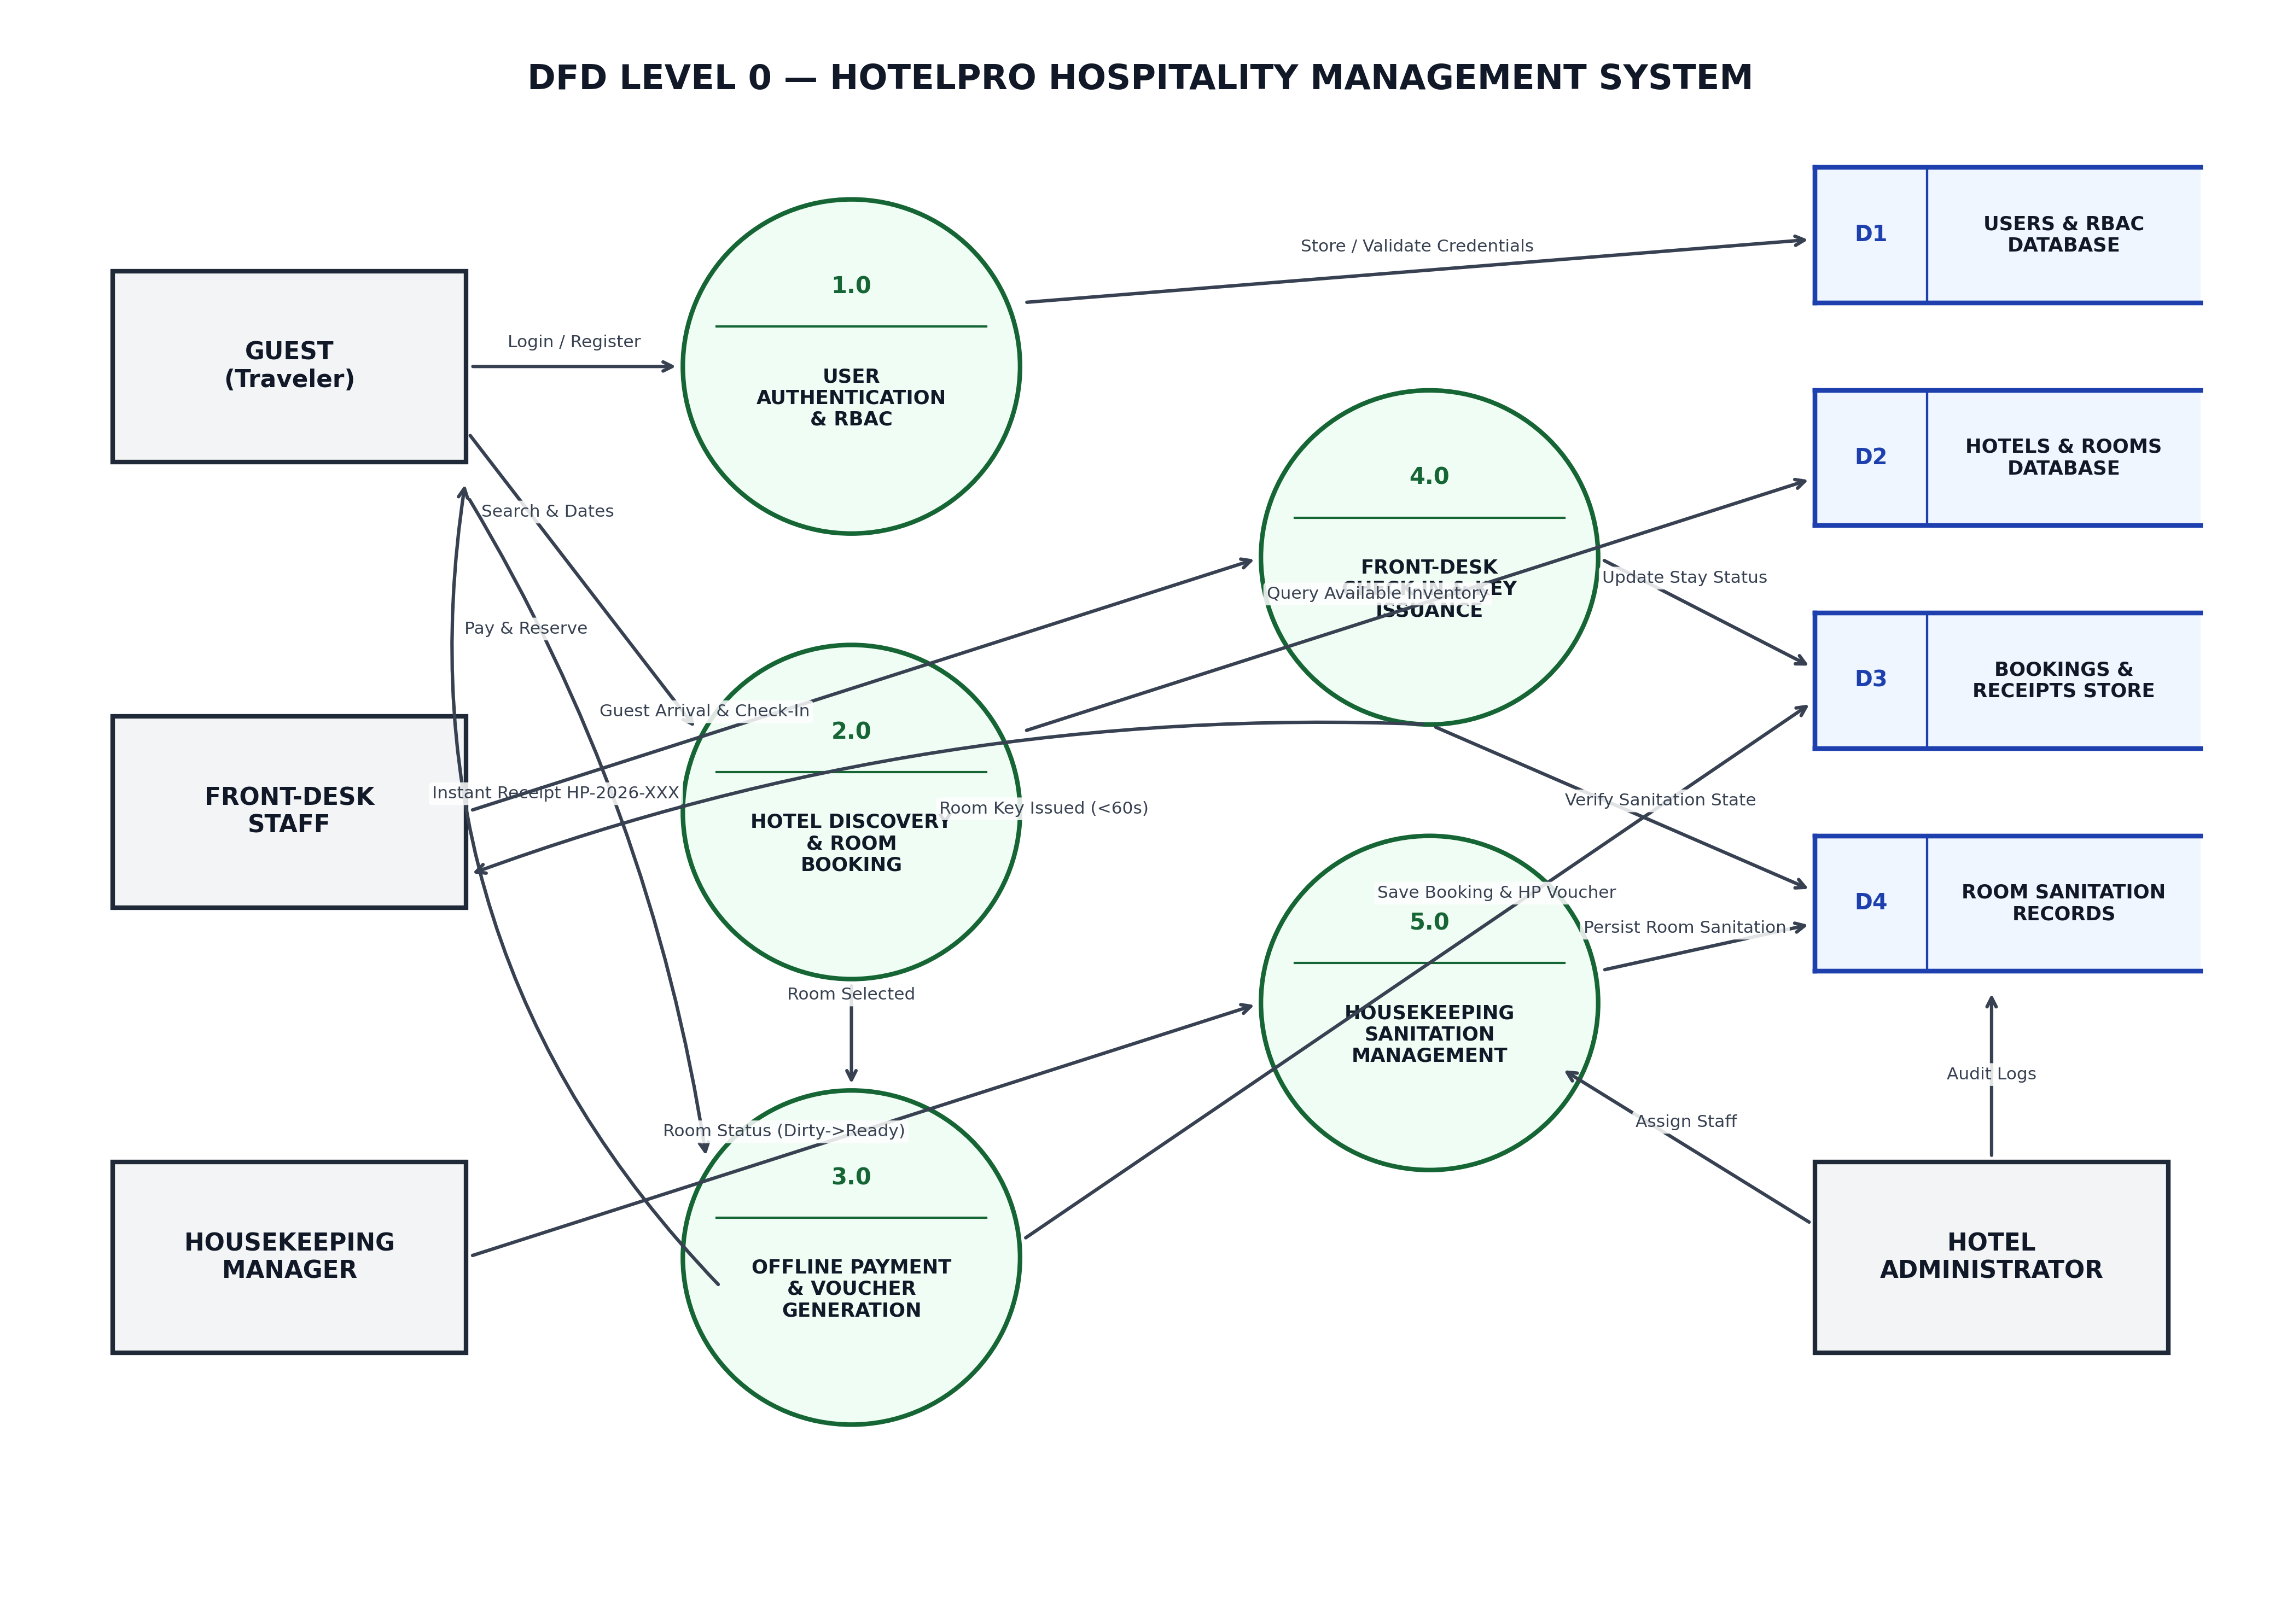

User Stories

User Story Table – HotelPro Hospitality Management System
User Type | Functional Requirement (Epic) | User Story / Task | Acceptance Criteria | Priority | Release
Guest | User Authentication | As a guest, I can register and log in securely with JWT session tokens. | User is authenticated; JWT token is stored securely in local state; redirected to hotel search. | High | Sprint-1
Tester / Evaluator | Demo Role Switching | As an evaluator/tester, I can use the 1-click demo role selector to switch roles instantly. | Clicking any demo credential card pre-fills form and logs in with appropriate RBAC view in 1 click. | High | Sprint-1
Guest | Hotel Search & Discovery | As a guest, I can search hotels by name, city, or category with real-time debounced filtering. | Matching hotel cards render in <50ms with live pricing, photo gallery, and star ratings. | High | Sprint-1
Guest | Destination Quick Chips | As a guest, I can click destination quick-chips (Mumbai, Jaipur, Goa, New Delhi) to filter inventory. | Clicking a destination chip filters hotel inventory immediately without full page reloads. | Medium | Sprint-1
Guest | Room Availability & Pricing | As a guest, I can select check-in/out dates and guest count to view live available room types. | Room inventory recalculates dynamically; total stay price updates based on night count. | High | Sprint-2
Guest | Offline Payment Sandbox | As a guest, I can complete booking checkout using the 100% offline payment sandbox (Card, UPI QR, Net Banking, Pay at Property). | Payment simulates in 600–850ms with 100% success rate, generating confirmed reference code HP-2026-XXX. | High | Sprint-2
Guest | Stay Voucher Modal | As a guest, I can securely view and print my stay receipt voucher via an authenticated in-page modal dialog in My Bookings. | Modal presents booking details, guest name, total amount, and QR verification badge with print styling. | High | Sprint-2
Security System | Voucher Route Guard | As a security guardrail, direct unauthenticated URL access to /booking/confirmation/:ref is blocked. | Direct access displays security warning modal redirecting user to login or My Bookings. | High | Sprint-2
Front-Desk Staff | Guest Check-In & Keys | As front-desk staff, I can look up arriving guests, assign physical room keys, and complete check-in in under 60 seconds. | Booking updates to 'Checked-In', room key card is linked, and stay folio is activated. | High | Sprint-3
Housekeeping | Room Sanitation Grid | As a housekeeping manager, I can view the room sanitation grid and toggle statuses (Dirty -> Cleaning -> Ready). | Sanitation updates synchronize in real-time, preventing front-desk staff from assigning dirty rooms. | High | Sprint-3
Hotel Admin | Executive Analytics | As an admin, I can view real-time occupancy trends via Recharts, RevPAR metric cards, and immutable audit logs. | Dashboard renders live occupancy charts, RevPAR KPIs, and chronologically ordered audit logs. | Medium | Sprint-3

